Tay Strong Foundation, Inc
Gala Event
Aneisha DeFreitas
2027
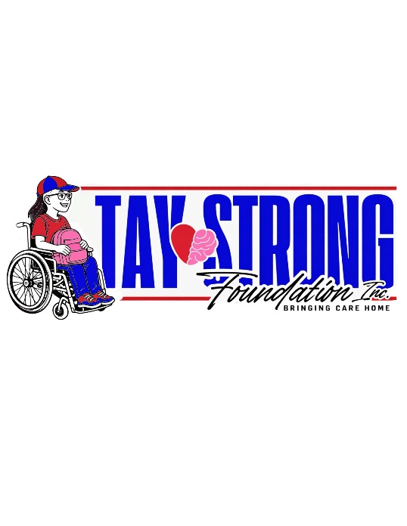
To Whom It May Concern,
We hope this letter finds you in the best of health and spirits. It is with great pride and purpose that we announce the creation of the #TayStrong Foundation—an organization dedicated to supporting individuals and families affected by brain injuries and other complex medical conditions.
Our mission is to provide critical support for brain injury patients who have encountered closed doors and limited resources. The #TayStrong Foundation is committed to helping families prepare their homes before their loved ones are discharged from the hospital by offering assistance with equipment, beds, and necessary home modifications. In addition, we aim to be a source of guidance, financial relief, and emotional support during times of crisis—whether it be help with a utility bill, rent, or a mortgage payment during a difficult transition.
The inspiration behind this foundation is deeply personal. My daughter Tay sustained a traumatic brain injury as a passenger in a friend’s car. She went from being completely independent to fully reliant on me for all her care. Our journey has been filled with countless challenges, navigating a system that too often fails to support families in their time of greatest need. I have had to fight, advocate, and seek information every step of the way.
One of the most difficult parts of this journey has been the lack of accessible resources and trained professionals available to assist families. This foundation was born from that struggle and from a strong desire to create change for others walking a similar path. Our goal is to grow into a national, and eventually international, network of support for brain injury patients, stroke survivors, children with disabilities, cancer patients, and individuals with multiple conditions requiring 24-hour care.
At the #TayStrong Foundation, we believe that every voice deserves to be heard and that families should not feel forgotten or unsupported. We are seeking sponsorships, donations, partnerships, and volunteers from companies, families, individuals, care facilities, hospitals, and grant providers who believe in this cause.
Nursing homes are slowly disappearing, and many no longer provide adequate or dignified care—despite receiving large sums through private pay and insurance. With the right training, tools, and support, more families can confidently care for their loved ones at home—where healing is often stronger and more meaningful.
Together, we can become the change our communities so desperately need.
With gratitude and hope,
ANEISHA DEFREITAS
Founder, #TayStrong Foundation
(860)471-7190 taystrongfoundation@gmail.com
Taystrongfoundation.org

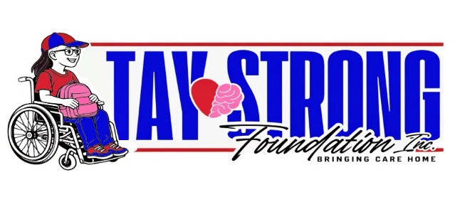
Our Mission
Turning one story into a movement of care, connection, and strength. We bridge the gaps left by the healthcare system, helping families focus on what matters most. Being able to provide care and recovery at home for their loved ones impacted by traumatic brain injuries and complex medical conditions. No family should have to choose between dignity and care. The Tay Strong Foundation bridges the gaps healthcare leaves behind by providing home modifications, medical equipment, financial relief, and training so families can focus on what matters most, healing together at home.
The Tay Strong Foundation supports individuals and families affected by traumatic brain injuries
and complex medical conditions by providing essential home modifications, medical equipment,
financial assistance, and caregiver resources. We empower families to safely care for their
loved ones at home by filling the critical gaps left by traditional healthcare systems.
WHY WE EXIST:
When Tay suffered a traumatic brain injury days after her 18th birthday, her mother stayed by
her side; day after day, decision after decision, fighting for the chance to bring her daughter
home. What she discovered was a healthcare system not built to support that kind of love.
● We believe healing, real healing happens at home
● We believe recovery doesn’t end at discharge
● We believe in action rooted in compassion
● We believe strength is rooted in family
And we believe Tay’s story is not the end, it’s the beginning!
The Tay Strong Foundation exists to turn one family's fight into a movement that lifts others.
We’re here to build a world where no one has to choose between love and care, where families
are equipped, not overlooked, and where healing is possible, not just hoped for. Together, we
are stronger. Together, we are Tay Strong.

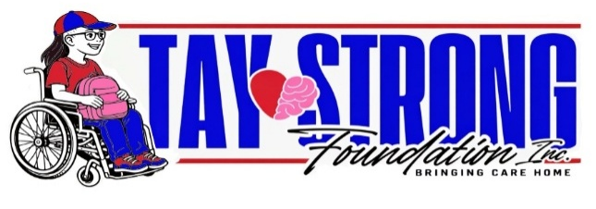
TAY'S STORY
Tay was a bright, creative, and compassionate young woman whose smile could light up a room. She loved art, cared deeply for others, and had big plans for her future. After graduation, she dreamed of attending art school to refine her talent for drawing and begin a tattoo apprenticeship. She was the kind of person who always looked out for others, especially her younger brother, whom she cared for with a nurturing, motherly love beyond her years.​But just two days after her 18th birthday, Tay’s life changed forever. As a passenger in a friend’s car, Tay was in a devastating accident that left her with a traumatic brain injury and 27 other life-threatening injuries. In an instant, she went from a vibrant, independent teenager with endless potential to a young woman in a semi-conscious state, fully reliant on others for care.
A MOTHER'S LOVE AND UNRELENTING FIGHT
From the moment the accident happened, Tay’s mother never left her side. She stayed in the hospital day after day, learning every detail of her daughter’s condition, speaking with doctors, and advocating for every treatment and therapy available. She faced not only the emotional toll of seeing her daughter in this condition but also the overwhelming reality of navigating a complex healthcare system that often fails families when they need it most.
When it became clear that Tay would need long-term care, her mother made a decision; with her heart to bring her home.​ But bringing Tay home wasn’t simple. It meant modifying the house to make it safe and accessible, purchasing specialized equipment like a wheelchair van, a tilt table, and therapy devices that insurance wouldn’t cover. It meant learning how to manage things like tracheotomy care, feeding tubes, mobility support, and more tasks most parents are never prepared to do.​
Despite endless challenges; financial, emotional, and physical, Tay’s mother remained determined. She chose love and dignity over convenience, proving that healing, even the slow kind, happens best at home surrounded by family.
THE SPARK THAT BECAME A MISSION
This journey revealed the deep gaps in resources, support, and education available to families like Tay’s. Most caregivers are left to figure it out on their own, facing not just the emotional weight of caregiving but the financial and logistical barriers that come with it. Through this struggle, the TayStrong Foundation was born. What started as one family’s fight to care for their daughter turned into a mission to help other families do the same, to give them the tools, resources, and hope they need to care for their loved ones at home.
TAY'S RECOVERY TODAY
It has been a little over two years since the accident. Tay is now stable and home with her family, where she continues to receive 24/7 care. She faces minor complications from time to time, but being home has allowed her to make small but meaningful strides in her recovery, like moving her arms to press a button. Her journey is still long, but her family remains hopeful that one day she will walk, talk, smile, and be herself again. Caring for Tay at home is not easy, but it is filled with love, hope, and the belief that she deserves dignity and comfort every step of the way.

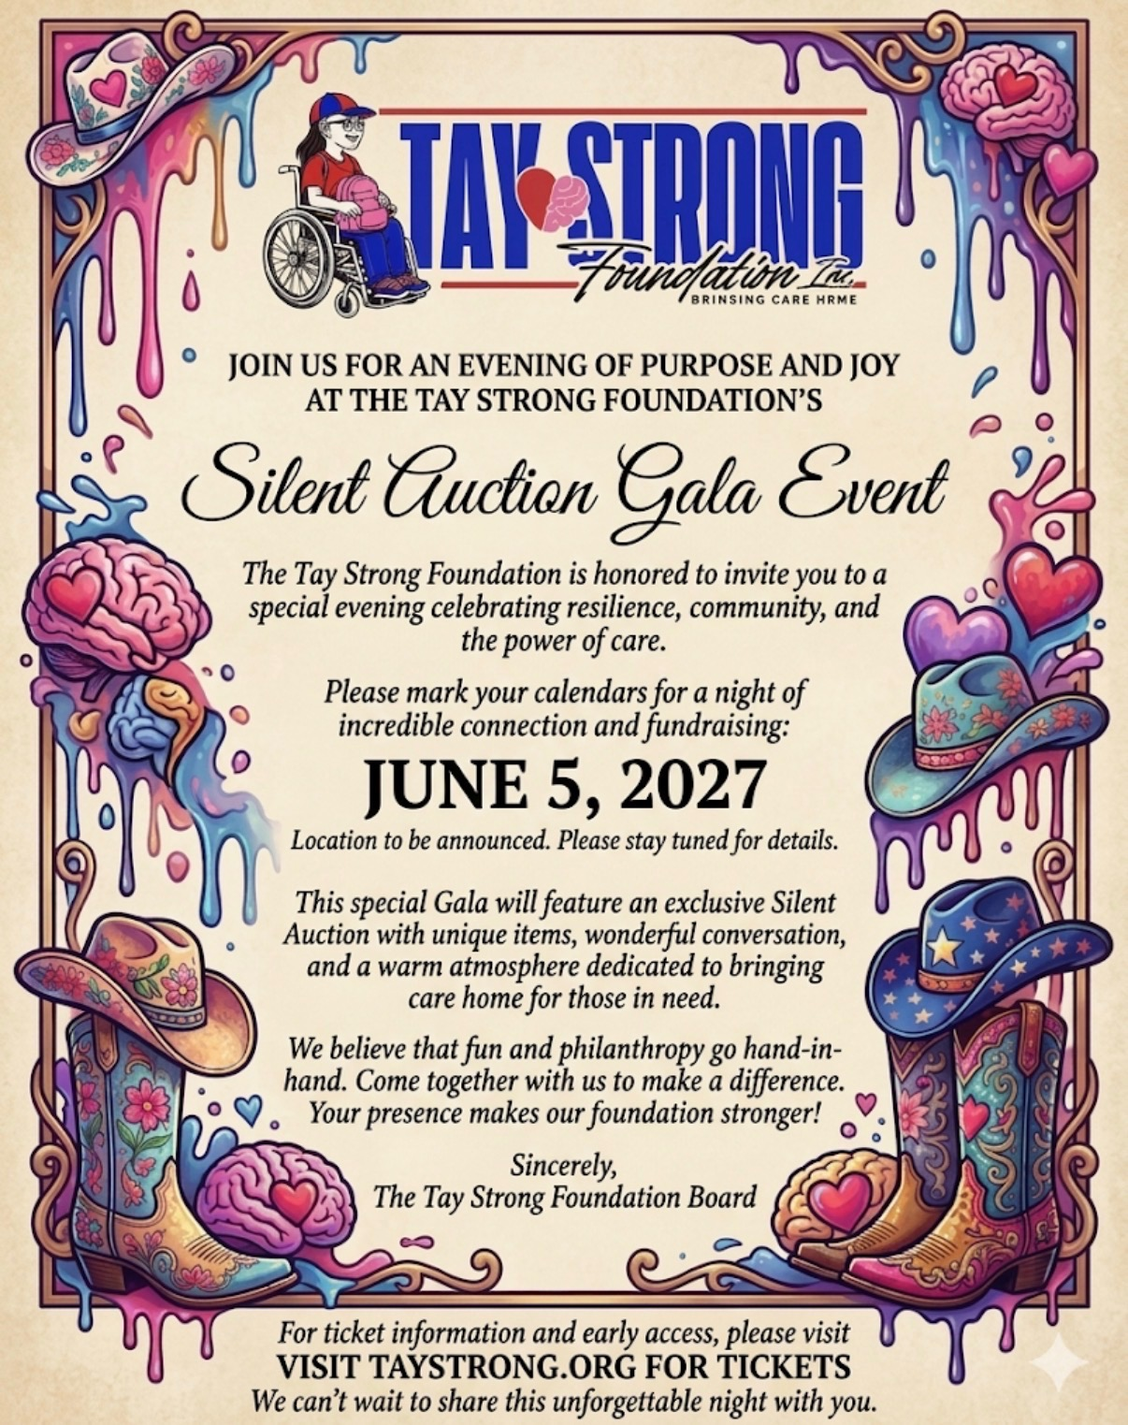

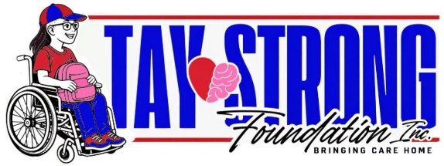

Aneisha DeFreitas (Founder)
Tay Strong Foundation, Inc
72 High Street Windsor, CT 06095
taystrongfoundation@gmail.com

Subject: Request for Sponsorship – Partnering to Bring Care Home

Dear Sponsor,
Every day, families navigating devastating medical crises find themselves fighting two battles: one for their loved one’s recovery, and another against a fragmented healthcare system. The Tay Strong Foundation was born out of this exact struggle. Founded after my daughter, Tay, survived a severe traumatic brain injury (TBI) from a catastrophic car accident, our mission is simple but vital: to bridge the critical gaps in the healthcare system and bring care home where it belongs.
Tay is currently in a vegetative state. While her resilience inspires everyone who knows her, her daily comfort, mobility, and quality of life depend heavily on specialized equipment. Right now, we are seeking dedicated sponsors to help our foundation move in the right direction to help others in similar conditions to Tay and bring them home.
We are looking for any type of sponsorship, silent auction items, or anything that you can contribute to achieve the goals in bringing families together after a traumatic event.
Moving for Those Who Can't: The "Movements 25 a Day" as well as “mobility for Tay” Campaign
Mobility is a gift we often take for granted. To honor Tay’s journey and advocate for those with limited mobility, we are launching a powerful movement initiative alongside this wheelchair sponsorship. We want to encourage people to move their bodies for the disabled community.
Through our "Movements 25 a Day for Tay" campaign, we will be challenging our community to complete 25 intentional movements every single day—whether that is 25 steps, 25 stretches, or 25 minutes of activity—to raise awareness for individuals who cannot move freely on their own. This wheelchair will be the cornerstone of Tay’s own daily mobility, and your company will be at the very heart of this inspiring message. Your Impact and Sponsorship Benefits families of all ages.

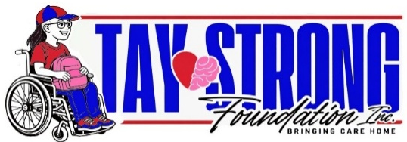

We would love your company to be the champion that makes this possible. By partnering with the Tay Strong Foundation, a registered 501(c)(3) non-profit organization, your generous donation is 100% tax-deductible.
In return for your life-changing support, we want to spotlight your company’s generosity across our growing community. We are fully committed to providing high-visibility promotion, including:
Weekly Highlights: Dedicated features showcasing the wheelchair in action, tied directly to our "Movements 25 a Day" updates, celebrating your company's role in making it happen.
Comprehensive Social Media Campaign: Robust promotion across all of our social media platforms, detailing how the equipment improves Tay's daily life and inspiring others to move for the disabled community.
Rich Media Content: Frequent, high-quality video updates and pictures highlighting positive milestones, comfort, and the direct impact of your sponsorship.
Detailed Product Features: In-depth descriptions of the wheelchair's specialized features, explicitly linking its benefits to your company’s philanthropic leadership.
By supporting this need, you are doing more than purchasing equipment—you are helping us spark a movement, challenge the limitations of the current healthcare system, and prove that the best place for a child to heal and be loved is at home with their family.
Thank you so much for your time, your compassion, and your consideration of this sponsorship. I would welcome the opportunity to speak with you briefly about how we can finalize this partnership and begin sharing your incredible impact with the world.

With deepest gratitude and resilience,
Founder, Tay Strong Foundation
Bringing Care Home

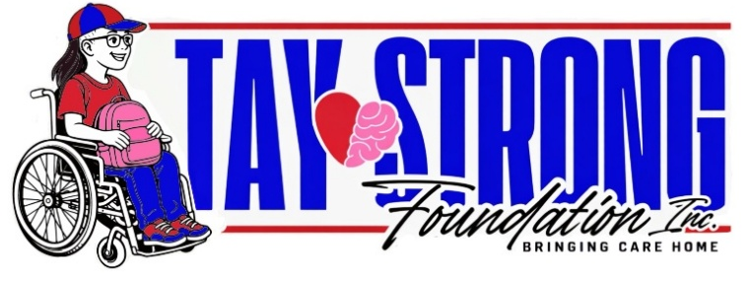
Sponsorships
- Food and Drink Sponsor- $3000 Donation, this level comes with full recognition with twelve tickets, full table, recognized table at the event, recognition on all social media platforms and websites, recognition from stage at the event. Top Tier Title Sponsor
- Title Level Sponsor -$2500 Donation, this level comes with ten tickets, top tier title sponsor on all event marketing, recognized table at the event, recognition on all social media platforms and websites, recognition from stage at the event.
- Hope and Inspiration Level Sponsor -$1000 Donation, this level comes with six tickets, recognized table at the event, recognition on all social media platforms and websites.
- Changing Lives Level Sponsor -$500 Donation, this level comes with four tickets, recognition on all social media platforms, websites, and on advertisements at events.
- Caring hearts and love Level Sponsor -$250 Donation, this level comes with two tickets, recognition on all social media platforms, website, and on advertisements at events.
- Tay Strong Foundation (TBI) Sponsor -$100 Donation, this level comes with recognition on all social medial platforms and websites, please let us know your cause that you want to highlight in your sponsorship; ie: CANCER, MS, AS, ASBERGHERS, TBI, VETERANS, STROKE, AUTISM, BLINDNESS, & MORE. SURVIVOR TABLE
- Disability Table Sponsor (Autism, MS, Cancer, Veteran (Purple Heart, ETC), TBI, & more- $300 Donation 3 Tickets, recognition on social media platforms and website. Gets to keep the center piece for the donation based on ability.
- General Admission Child 13 years or younger -$65
- Full Table Sponsor -$1500 Donation, this level comes with eight ticket Discount Sale with recognition on all social media platforms, recognized table at the event, recognition from stage at the event. (EARLY BIRD SPECIAL) LIMITED TIME ONLY
- If you are unable to attend and would still like to donate, it includes recognition on all social media and website platforms as well as advertisement. (YOU CAN REFER OR USE CALENDAR PROVIDED)
Every dollar raised goes directly towards bringing a loved one home with dignity. Whether it is a specialized piece of therapy gear or a month of caregiver support, your generosity changes the narrative for a family in crisis.
- $50 Donation- Vital supplies for caregiver training kits
- $100 Donation- A session for caregiver support or help with service.
- $500+- Essential medical equipment and assistance with home modifications.
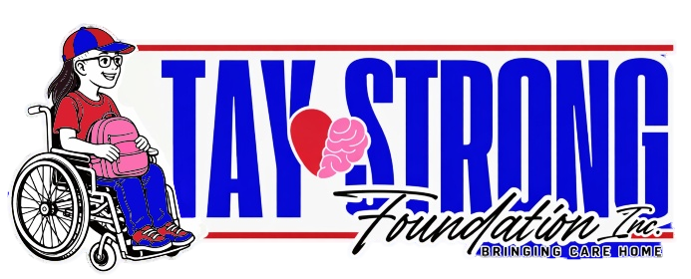
Small Business Sponsorship Application Form

Contact Person
First Name______________________________________LastName____________________________________________

Name of your organization

Email Address

_____________________________________________________________________________________________________________

- Phone Number __________________________

- What type of sponsorship are you interested in?
___ Financial Donation
___ Event Sponsorship
___ Product or service partnership

Specific Sponsorship proposal

Signature _________________________

NOTE: Please provide us with a copy of your logo in order to properly place it on our website, and all media platforms.

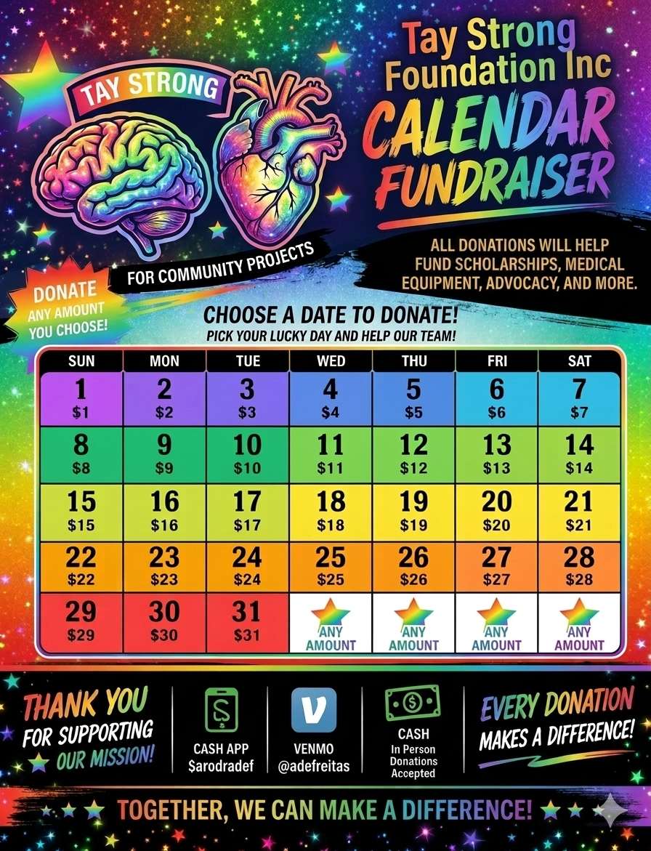
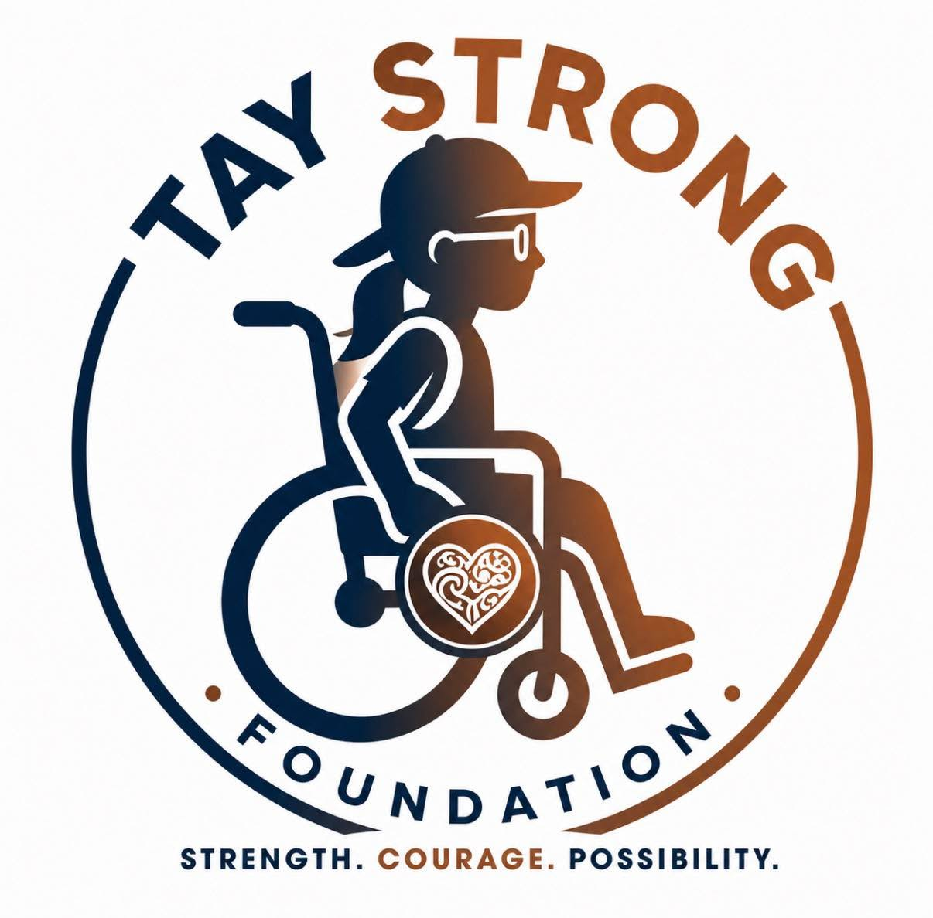

Taystrongfoundation.org taystrongfoundation@gmaill.com (860)471-7190

